Contact: Matthew Poyzer
Flint Group
matt.poyzer@flint-group.com
Work: (701) 499-2614
Cell: (701) 388-6521

Introducing the D1105 P2 Hybrid Engine from Kubota
The switch between engine and electric motor drive for your application needs

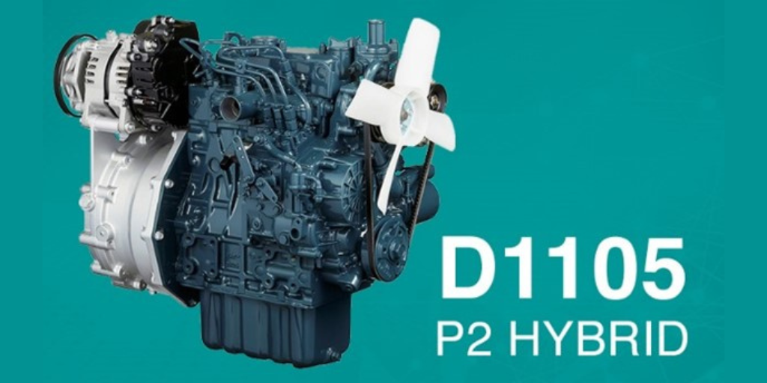

LAS VEGAS (March 1, 2023) – As Kubota gears up for CONEXPO 2023 in March, they stand on their commitment to a carbon neutral future.

With Kubota’s new D1105 P2 Hybrid system, the company has continued to build on this investment, earning trust among many end users and equipment manufacturers. Kubota is proud to introduce the D1105 P2 Hybrid engine as a power source complying with EPA/CARB Tier 4 + EU Stage V. The engine was first introduced at the Bauma 2022 show in Germany however, Kubota is excited to announce its debut in the states for CONEXPO 2023!

What to expect in the D1105 P2 Hybrid engine

Offering a rated output of 28.4 HP (18.5 kW) at 3000 rpm, this engine comes with a powerful punch. The newly developed P2 Hybrid system from Kubota offers the ability to switch between engine drive and electric motor drive while in operation. The engine can be used when moving between locations, but if there are areas where emissions or noise are a concern, the engine can be stopped and switched to the electric motor.

The D1105 P2 Hybrid offers a one-way clutch that is incorporated into the Kubota supplied gearbox, reducing the system’s overall weight and size, which is approximately 7.9 inches in width. The clutch is also provided by Kubota, allowing more flexibility in the application design. A hydraulic pump can then be mounted to the gearbox to withdraw power. The start of production on the D1105 P2 Hybrid is scheduled for 2025.
Learn more about the D1105 P2 Hybrid here.

CONEXPO 2023

We look forward to seeing you at the upcoming CONEXPO 2023 exhibition in Las Vegas! Kubota will be showcasing an impressive display at booth S84415 starting March 14.

ABOUT KUBOTA ENGINE AMERICA:
Kubota Engine America (KEA) started as an engine division of Kubota Tractor Corporation in 1982. The Engine Division was dedicated to the sales and reinforcement of technical support of the expanding industrial diesel engine market in the United States. Kubota Corporation
and KEA pioneered the compact, high-density diesel market as an alternative to small gasoline engines. In response to the continued rise in diesel engine demand in the US market, KEA was formed in 1998 as an independent company and a subsidiary of Kubota Corporation and is headquartered in Lincolnshire, Illinois. Kubota is the world’s leading manufacturer of both compact diesel and gasoline engines, for industrial, agricultural, construction and generator applications. The company has built an extensive engine and generator distribution network with more than 800 dealers in North America, South America and the Caribbean to support its customer base. Kubota prides itself on its track record for reliability and engineering that fulfills its “For Earth, For Life” philosophy.

WEBSITE: kubotaengine.com
FACEBOOK: Kubota Engine America

# # #

